**Essential configuration values**

EIGRP Router doesn’t trust anyone blindly. It checks following configuration values to insure that requesting router is eligible to become his neighbor or not.

1. Active Hello packets
2. AS Number
3. K-Values

**Active Hello packets**

EIGRP uses hello packets to maintain the neighborship between routers. It uses them for neighbor discovery and recovery process. Hello packets are periodically sent from all active interfaces.

By default when we enable EIGRP routing, all interfaces (that meet network command criteria) become participate of it. EIGRP allows us to exclude any interface from it.

**Passive interface**

***passive-interface*** command is used to exclude an interface from EIGRP. Passive interface command is a double edged sword. If used carelessly, it could bring entire network down. Once you marked an interface as passive, EIGRP will never send a hello packet from it. And we know that hello packet is first condition of EIGRP neighborship. In this situation EIGRP neighborship will not take place on this interface. This could be critical if this interface is the only way to connect with other routers. Making this interface as passive will close all possible doors to communicate with those networks.

So our first condition that needs to be fulfilled in order to become an EIGRP neighbor is an active interface generating hello packets. Two routers will become neighbors only when they see each other's hello packets on a common network.

EIGRP sends hello packets from all active interfaces in hello interval. Hello interval is a time duration that EIGRP takes between two hello packets. Default hello interval for high bandwidth link is 5 seconds. For low bandwidth links, hello interval is 60 seconds.

* Ethernet, Token Ring, Point to Point serial links, HDLC leased lines are the examples of high bandwidth link.
* Multipoint circuits, Multipoint ATM, Multipoint Frame Relay, ISDN and BRIs are the example of low bandwidth links.

An EIGRP router must receive hello packets continuously from its neighbors. If it does not receive hello packets from any neighbor in hold down time, it will mark that neighbor as dead.

Hold time is the time duration that an EIGRP router waits before marking a router dead without receiving a hello packet from it. Typically hold down time is three times of hello interval. So for high bandwidth link it would be 15 seconds and 180 seconds for slow bandwidth link. We can adjust hold down time with *ip hold-time eigrp* command.

EIGRP uses multicast and unicast for hello packets delivery. It uses 224.0.0.10 IP address for multicast. Since hello packets do not have any important routing information, they need not be acknowledged.

Basically Hello packets perform two essential functions of EIGRP.

* Find another EIGRP router in network and help in building neighborship.
* Once neighborship is built, check continuously whether neighbor is alive or not.

**Adjacency**

Neighborship is referred as adjacency in EIGRP. So when you see New Adjacency in log, take it for new neighborship. It indicates that a new neighbor is found and neighborship with it has been established.

**AS Number**

An AS is a group of networks running under a single administrative control. This could be our company or a branch of company. Just like Subnetting AS is also used to break a large network in smaller networks.

AS creates a boundary for routing protocol which allow us to control how far routing information should be propagated. Beside this we can also filter the routing information before sharing it with other AS systems. These features enhance security and scalability of overall network.

Basically AS concept was developed for large networks. Routing protocols which were developed for small networks such as RIP do not understand the concept of AS systems.

There are two types of routing protocols IGP and EGP.

* **IGP** (Interior Gateway Protocol) is a routing protocol that runs in a single AS such as RIP, IGRP, EIGRP, OSPF and IS-IS.
* **EGP** (Exterior Gateway Protocol) is a routing protocol that performs routing between different AS systems. Nowadays only BGP (Border Gateway Protocol) is an active EGP protocol.

To keep distinguish between different autonomous systems, AS numbers are used. An AS number start from 1 and goes up to 65535. Same as IP addresses, AS numbers are divided in two types; Private and public.

* **Public AS Numbers**: - We only need to use public numbers if we connect our AS with Internet backbone through the BGP routes. IANA (Numbers Authority) controls the public AS numbers.
* **Private AS Numbers**: - Private AS numbers are used to break our internal network into the smaller networks.

EIGRP routers that belong to different ASs don’t become neighbors therefore they don’t share any routing information.

So our second condition that needs to be fulfilled in order to become EIGRP neighbor is the same AS number. Two routers will become neighbors only when they see same AS number in each other's hello packets.

**K Values**

EIGRP may use five metric components to select the best route for routing table. These are Bandwidth, Load, Delay, Reliability and MTU. By default EIGRP uses only two components; Bandwidth and delay. With K-Values we can control which components should be used in route metric calculation. For five metric components we have five K values.

|  |  |
| --- | --- |
| **K Values** | **Metric components** |
| K1 | Bandwidth |
| K2 | Load |
| K3 | Delay |
| K4 | Reliability |
| K5 | MTU |

Two routers must use same K Values in order to become the EIGPR neighbor. For example if one router is using three K- Values (K1, K2 and K3) while second router is using default K values (K1 and K3) then these two routers will never become neighbor.

In order to become EIGRP neighbor two routers must use same K values.

**EIGRP Neighbor Discovery process**

Step 1:- First router R1 sends a hello packet from all active interfaces. This packet contains essential configuration values which are required to be a neighbor.

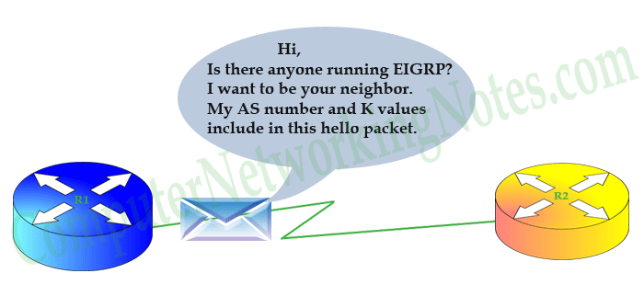

Step 2:- Receiving router R2 will compare these values with its own configuration values. If both necessary values match (AS number and K-values), it will reply with a routing update. This update includes all routes information from its routing table excluding one route. The route which it learned from the same interface that bring hello packet to it. This mechanism is known as split horizon. It states that if a router receives an update for route on any interface, it will not propagate same route information back to the sender router on same port. Split horizon is used to avoid routing loops.

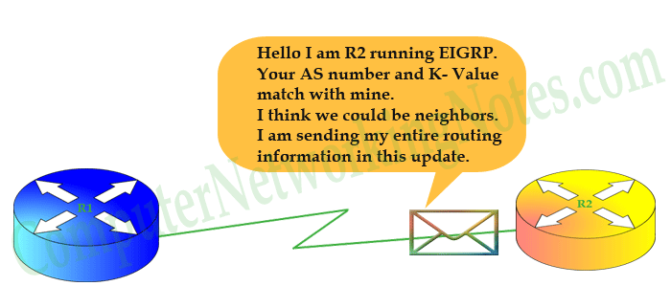

Step 3:- First router will receive R2’s routing update and sends an acknowledgement message back to R2.

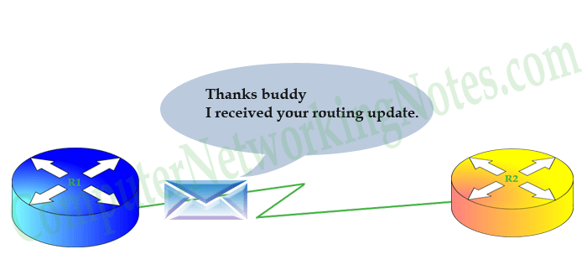

Step 4:- R1 will sync its EIGRP topology table with routing information that it received in routing update. It will also send a routing update containing all route information from its routing topology to R2.

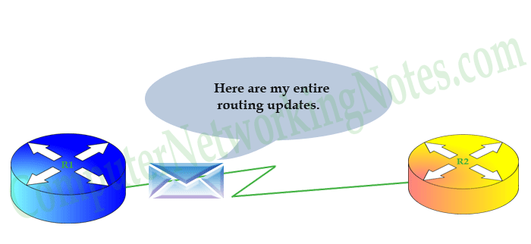

Step 5:- R2 will respond with an acknowledgement message. It will also sync its EIGRP topology table with routing information that it received in routing update.

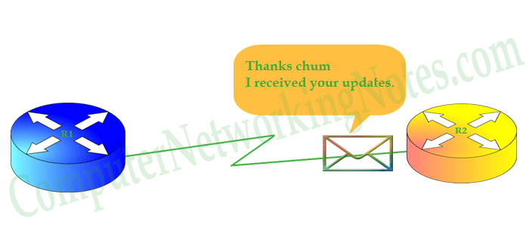

At this point, the two routers have becomes neighbor. Now they will maintain this neighborship with ongoing hello packets. If they see any change in network, they will update each other with partial updates.

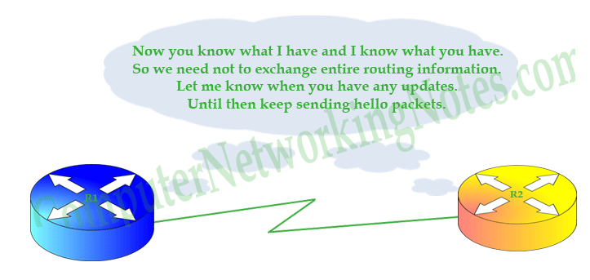

Partial update contains information only about the recent change.

That’s all for this part. In this part we explained how two routers become EIGRP neighbors.